[Finance and economics](https://www.economist.com/finance-and-economics/) | Buttonwood

What a third world war would mean for investors

Global conflicts have a habit of sneaking up on money-managers

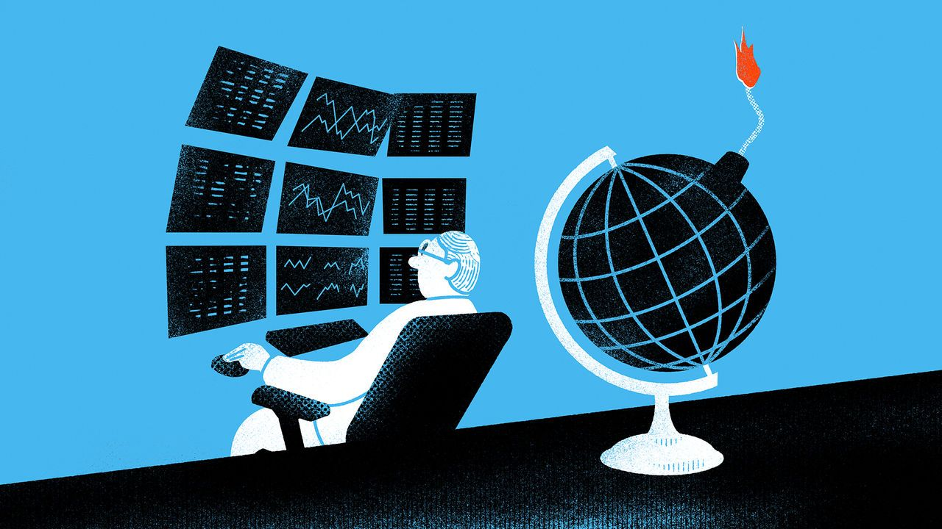

mage: satoshi kambayashi

Europe had been moving towards the

slaughterhouse

for years, and by 1914 a conflict was all but inevitable—that, at least, is the argument often made in hindsight. Yet at the time, as Niall Ferguson, a historian, noted in a paper published in 2008, it did not feel that way to investors. For them, the first world war came as a shock. Until the week before it erupted, prices in the bond, currency and money markets barely budged. Then all hell broke loose. “The City has seen in a flash the meaning of war,” wrote this newspaper on August 1st 1914.

欧洲多年来一直在朝着屠宰场走去，因此，一场冲突几乎是不可避免的——至少，这是后来人们常常事后评论的论点。然而，正如历史学家尼尔·弗格森在2008年发表的一篇论文中所指出的，当时的投资者并没有察觉到这一点。对他们而言，第一次世界大战的爆发让他们颇为震惊。直到战争爆发前的那一周，债券、货币和金融市场的价格几乎没有变化。然后一切都乱套了。“伦敦金融城一瞬间看到了战争的真正威力”，1914年8月1日，《经济学人》写道。

Could financial markets once again be underpricing the risk of a global conflict? In the nightmare scenario, the descent into a third world war began two years ago, as Russian troops massed on the Ukrainian border. Today Israel’s battle against Hamas has the frightening potential to spill across its borders. American military support is crucial to both Ukraine and Israel, and in Iraq and Syria the superpower’s bases have come under fire, probably from proxies of Iran. Should China decide it is time to take advantage of a distracted superpower and invade Taiwan, America could all too easily end up being drawn into three wars at once. The rest of the world risks those wars interlocking and turning into something even more devastating.

金融市场是否会再次低估发生全球性冲突的风险吗？在噩梦般的情景下，第三次世界大战获取开始于两年前，即俄罗斯军队集结在乌克兰边境的时候。如今，以色列与哈马斯的战斗有可能波及到以色列边境。美国的军事支持对乌克兰和以色列都至关重要，而这个超级大国在伊拉克和叙利亚的基地也遭到了攻击，这些攻击可能来自伊朗的代理人。如果中国认为是时候利用一个心烦意乱的超级大国入侵台湾，美国很可能会被同时卷入三场战争。世界其他国家也可能相继卷入，导致形势进一步恶化。

This scenario would of course place financial damage a long way down the list of horrors. Even so, it is part of an investor’s job to consider exactly what it would mean for their portfolio. So far the possibility of a world war has barely caused a tremor in the markets. True, they have for some time now been more seized by fear than greed. Bond prices have been turbulent, even for supposedly risk-free American Treasuries, and yields have been climbing for most of this year. Stock indices in America, China and Europe have fallen for three consecutive months. Yet this choppiness can all be plausibly explained by peacetime factors, including outsized government borrowing, interest-rate expectations and shareholders whose previous optimism had got the better of them.

当然，和其他可怕的事情相比，经济损失显得没有那么重要。即便如此，投资者仍需要考虑这种情况对投资组合意味着什么，这也是投资者们工作的一部分。至今，世界大战爆发的可能性在市场中几乎没有引起震荡。诚然，一段时间依赖，市场上的恐慌多余贪婪。债券价格一直波动不安，即使是被认为无风险的美国国债，其收益率在今年大部分时间都在上升。美国、中国和欧洲的股票指数连续三个月下跌。然而和平时期的各种因素可以合理的解释这种波动，包括政府过过度借贷、利率预期以及之前过于乐观的股东的因素。

In short, it does not look anything like the panic you might expect if the odds of the world entering into war were edging higher. The brightest conclusion is that such odds really are close to zero. A darker one is that, like the investors of 1914, today’s may soon be blindsided. History points to a third possibility: that even if investors expect a major war, there is little they can do to reliably profit from it.

简而言之，市场并没有出现像预期中随着世界卷入战争的可能性增加而引发的恐慌。最好的结果是这种可能性实际上几乎趋于零。更坏的结论是，就像1914年的投资者一样，今天的投资者可能很快会遭受意外打击。历史经验表明还有第三种可能性：即使投资者预期会发生一场大规模战争，他们几乎无法从中稳定获利

The easiest way to understand this is to imagine yourself in 1914, knowing that the first world war was about to arrive. You would need to place your bets quickly—within weeks, the main exchanges in London, New York and continental Europe would be closed. They would stay that way for months. Would you be able to guess how many, and which way the war might have turned by then? If you wisely judged American stocks to be a good bet, would you have managed to trade with a broker who avoided bankruptcy amid a liquidity crisis? You might have decided, again wisely, to trim positions in soon-to-be war-strained government debt. Would you have guessed that Russian bonds, which would experience a communist revolution and Bolshevik-driven default, were the ones to dump completely?

要更好地理解这一点，可以假设你置身于1914年，已经知道第一次世界大战即将到来。你需要迅速下注——几周内，伦敦、纽约和欧洲大陆的主要交易所将关闭，关闭时间将长达数月。那时，你能否预测战争发生的规模和方向吗？如果你明智地判断美股是一个不错的选择，你是否能够找到一位在流动性危机中避免破产的经纪人进行交易？你可能同样明智地决定减少对即将面临战争压力的政府债务的持仓。但你会预料到俄国债券将经历一场共产主义革命和布尔什维克主导的违约，应该完全抛售吗？

War, in other words, involves a level of radical uncertainty far beyond the calculable risks to which most investors have become accustomed. This means that even previous world wars have limited lessons for later ones, since no two are alike. Mr Ferguson’s paper shows that the optimal playbook for 1914 (buy commodities and American stocks; sell European bonds, stocks and currencies) was of little use in the late 1930s. Investors in that decade did try to learn from history. Anticipating another world war, they sold continental European stocks and currencies. But this different war had different winning investments. British stocks beat American ones, and so did British government bonds.

换句话说，战争涉及到的无法计算的不确定性，远远超出大多数投资者习惯的可估算风险。这意味着之前的世界大战的参考意义不大，因为每场战争都不尽相同。弗格森先生的论文指出，1914年的最佳策略（购买大宗商品和美股；出售欧洲债券、股票和货币）在上世纪30年代末几乎无用。那个时期的投资者确实试图从历史中吸取教训。他们预料到另一场世界大战，因此卖掉了欧洲大陆的股票和货币。然而，与一站不同，这场战争的获胜投资方式也不同。英国股票表现优于美国股票，英国政府债券也是如此。

Today there is a greater and more terrible source of uncertainty, since many of the potential belligerent powers wield nuclear weapons. Yet in a sense, this has little financial relevance. After all, in a nuclear conflagration your portfolio would be unlikely to rank highly among your priorities. The upshot of it all? That the fog of war is even thicker for investors than it is for military generals, who at least have sight of the action. If the worst happens, future historians might wonder about the seeming insouciance of today’s investors. They will only be able to do so because, for them, the fog will have cleared.

如今，存在着一种更加巨大而可怕的不确定性，因为许多可能成为交战方的国家拥有核武器。然而从某种意义上来看，这似乎与金融毫不相关。毕竟，在核大战中，你的投资组合很可能不会成为你优先考虑的事项之一。总结起来，对于投资者来说，与军事将领相比，投资者眼前战争的迷雾甚至更加浓一些，前者至少能够亲眼目睹战争的发展。如果最坏的情况发生，当今投资者们的看似漠不关心，可能会令未来的历史学家感到困惑。他们之所以能够这样思考，是因为对于他们来说，迷雾已经消散了。